SQL analysis

Data analyst: Abraham Cedeño

Date: 9th October 2022

In this document, I will use BIGQUERY to answer the S.M.A.R.T questions I created when I started the data analysis.

**Data category 1 - Bike preferences**

**SMART Question one:** “What was the percentual distribution of bike preferences among casual and member riders in the last 12 months?”

**Answer:** I performed the following queries to answer my question, then I made a visualization to better share my findings.

SELECT COUNT(rideable_type) AS electric_bike_preference_among_casual_riders

FROM `capstone-1-abraham.Trip_data_v2.BikeTrips_todos`

WHERE member_casual = 'casual' AND rideable_type = 'electric_bike'

SELECT COUNT(rideable_type) AS classic_bike_preference_among_casual_riders

FROM `capstone-1-abraham.Trip_data_v2.BikeTrips_todos`

WHERE member_casual = 'casual' AND rideable_type = 'classic_bike'

SELECT COUNT(rideable_type) AS docked_bike_preference_among_casual_riders

FROM `capstone-1-abraham.Trip_data_v2.BikeTrips_todos`

WHERE member_casual = 'casual' AND rideable_type = 'docked_bike'

SELECT COUNT(rideable_type) AS electric_bike_preference_among_member_riders

FROM `capstone-1-abraham.Trip_data_v2.BikeTrips_todos`

WHERE member_casual = 'member' AND rideable_type = 'electric_bike'

SELECT COUNT(rideable_type) AS classic_bike_preference_among_member_riders

FROM `capstone-1-abraham.Trip_data_v2.BikeTrips_todos`

WHERE member_casual = 'member' AND rideable_type = 'classic_bike'

SELECT COUNT(rideable_type) AS docked_bike_preference_among_member_riders

FROM `capstone-1-abraham.Trip_data_v2.BikeTrips_todos`

WHERE member_casual = 'member' AND rideable_type = 'docked_bike'

**Visualizations**

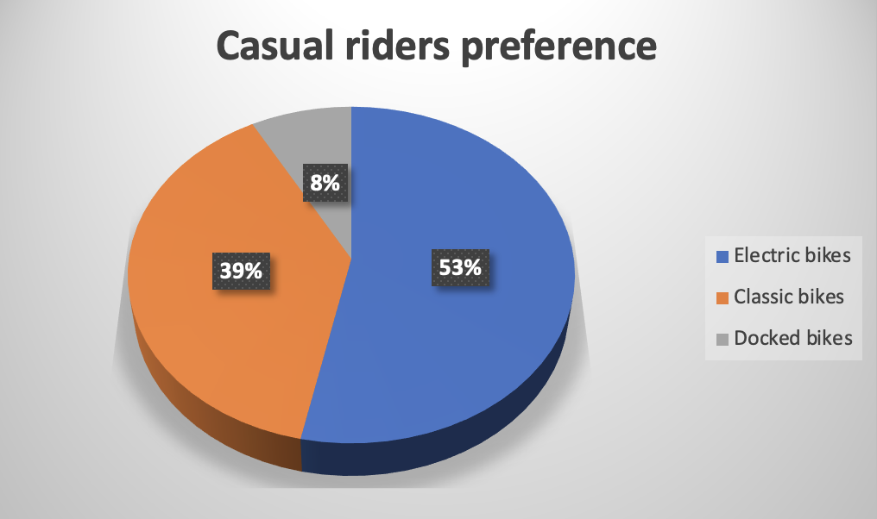

**Data category 2 - Trips start day and time**

**SMART Question two:** “On which days of the week have our members used more often the services in the last 12 months?”

**Answer:** I performed the following queries to answer my question, then I made a visualization to better share my findings.

SELECT COUNT (day_of_week) AS Trips_per_day_casual_riders, day_of_week

FROM `capstone-1-abraham.Trip_data_v2.BikeTrips_todos`

WHERE member_casual = 'casual'

GROUP BY

day_of_week

Order by

Trips_per_day_casual_riders DESC

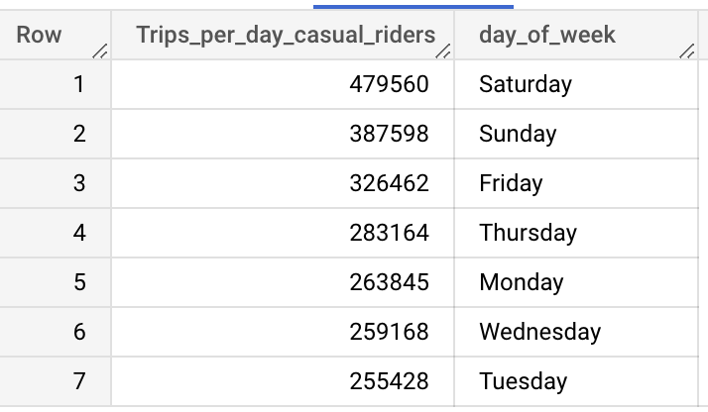

SELECT COUNT (day_of_week) AS Trips_per_day_member_riders, day_of_week

FROM `capstone-1-abraham.Trip_data_v2.BikeTrips_todos`

WHERE member_casual = "member"

GROUP BY

day_of_week

Order by

Trips_per_day_member_riders DESC

SELECT COUNT (day_of_week) AS Trips_per_day_both_riders, day_of_week

FROM `capstone-1-abraham.Trip_data_v2.BikeTrips_todos`

GROUP BY

day_of_week

Order by

Trips_per_day_both_riders DESC

**Visualizations**

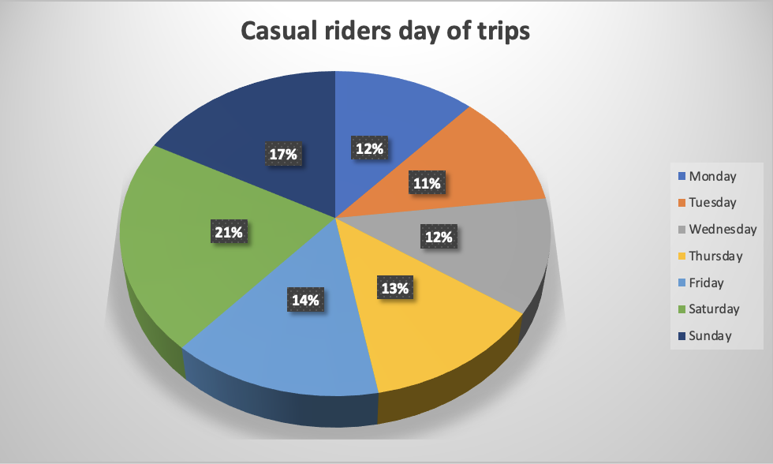

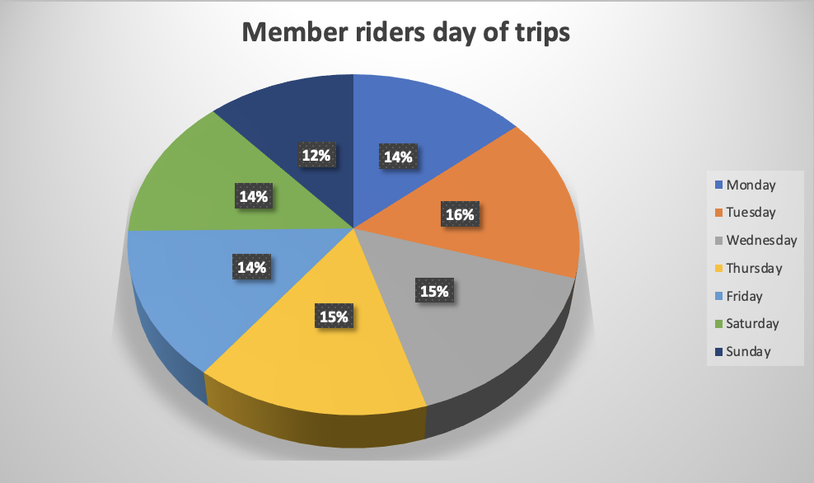

**SMART Question three:** “At which times of the day have our members used more often the services in the last 12 months?”

**Answer:** Although with SQL I can count the trips at any time, unfortunately, because I’m using a free account, I cannot export that much data from BIGQUERY, therefore I wouldn’t be able to visualize the data and make some findings. I will try to answer this question with R later.

**Data category 3 - Trips end day and time**

**SMART Question four:** “What was the average trip duration of our members in the last 12 months?

**SMART Question five:** “What was the average trip duration of our casual riders in the last 12 months?”

**Answer:** To answer both questions I used the following queries. Then I made a visualization to better share my findings.

SELECT

TIME_ADD(TIME '00:00:00', INTERVAL CAST(AVG(TIME_DIFF(ride_length, TIME '00:00:00', SECOND)) AS INT64) SECOND) average_trip_duration_casual_riders

FROM `capstone-1-abraham.Trip_data_v2.BikeTrips_todos`

WHERE member_casual = 'casual'

SELECT

TIME_ADD(TIME '00:00:00', INTERVAL CAST(AVG(TIME_DIFF(ride_length, TIME '00:00:00', SECOND)) AS INT64) SECOND) average_trip_duration_member_riders

FROM `capstone-1-abraham.Trip_data_v2.BikeTrips_todos`

WHERE member_casual = 'member'

SELECT

TIME_ADD(TIME '00:00:00', INTERVAL CAST(AVG(TIME_DIFF(ride_length, TIME '00:00:00', SECOND)) AS INT64) SECOND) average_trip_duration_both_riders

FROM `capstone-1-abraham.Trip_data_v2.BikeTrips_todos`

**Visualizations**

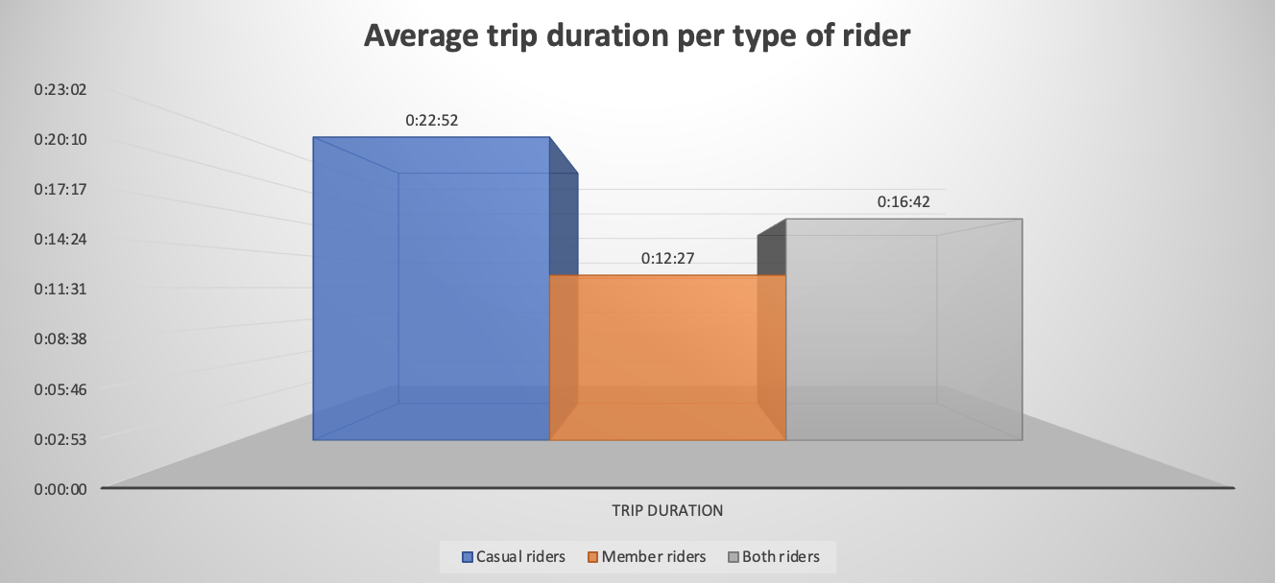

**Data category 4 – Start stations**

**SMART Question six:** “On which stations did the member riders start their rides more often in the last 12 months?

**Answer:** When I started to do some queries I found out that data need more cleaning because I have two start stations named the same but one with a capital letter.

To clean the data I used the next query.

SELECT * except(start_station_name),

CASE

WHEN start_station_name = 'Start_station_none_given' THEN 'start_station_none_given'

ELSE start_station_name

END AS cleaned_start_station_name

FROM `capstone-1-abraham.Trip_data_v2.BikeTrips_todos`

An then I saved this new table in a new dataset called Trip_data_v3

Then I did the following query to find the top 11 started stations of member and casual rider trips. After that, I make some visualizations.

SELECT COUNT (cleaned_start_station_name) AS Number_of_trips, cleaned_start_station_name AS start_station_of_casual_riders

FROM `capstone-1-abraham.Trip_data_v3.BikeTrips_todos_v1`

WHERE member_casual = 'casual'

GROUP BY

cleaned_start_station_name

Order by

COUNT (cleaned_start_station_name) DESC

LIMIT 11

SELECT COUNT (cleaned_start_station_name) AS Number_of_trips, cleaned_start_station_name AS start_station_of_member_riders

FROM `capstone-1-abraham.Trip_data_v3.BikeTrips_todos_v1`

WHERE member_casual = 'member'

GROUP BY

cleaned_start_station_name

Order by

COUNT (cleaned_start_station_name) DESC

LIMIT 11

SELECT COUNT (cleaned_start_station_name) AS Number_of_trips, cleaned_start_station_name AS start_station_of_member_riders

FROM `capstone-1-abraham.Trip_data_v3.BikeTrips_todos_v1`

GROUP BY

cleaned_start_station_name

Order by

COUNT (cleaned_start_station_name) DESC

LIMIT 11

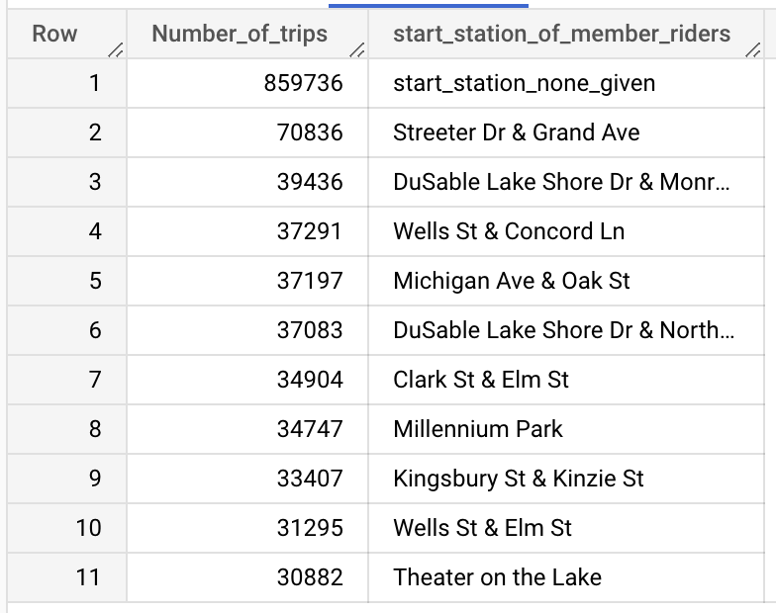

**Visualizations**

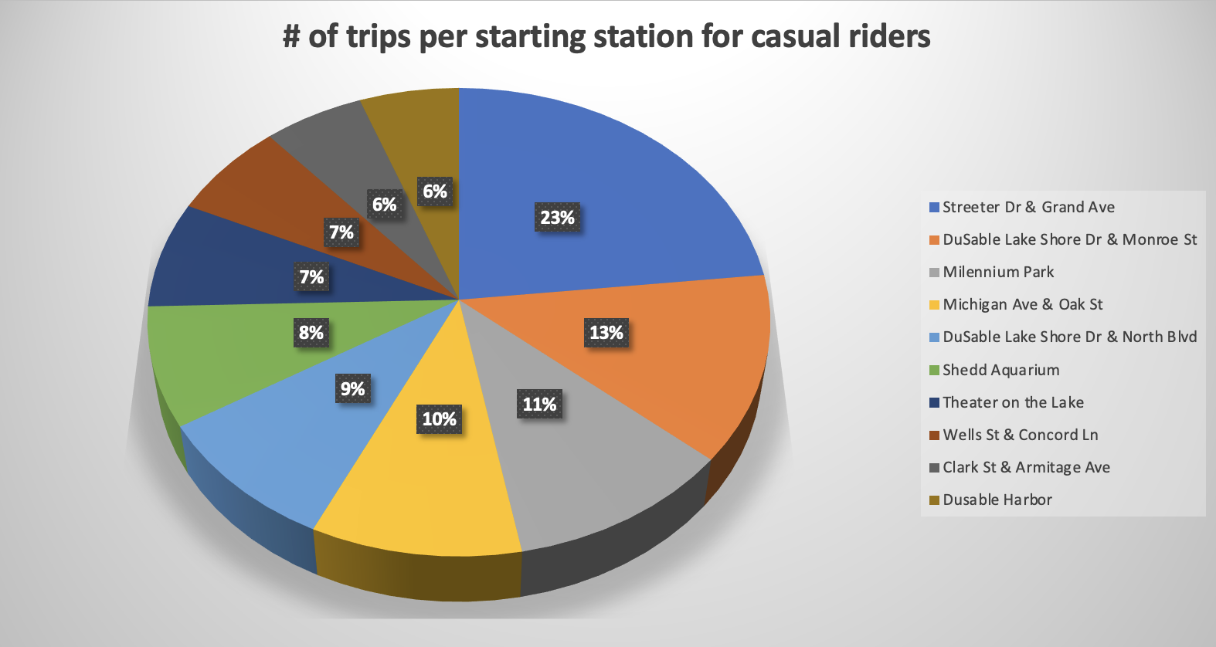

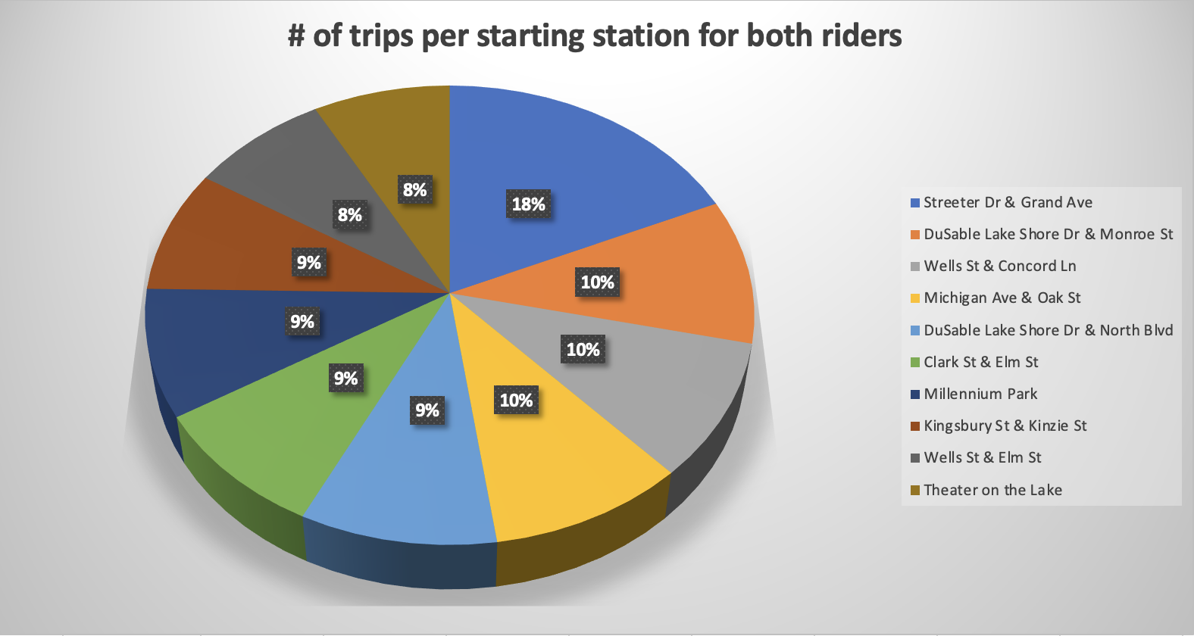

**Data category 5 – End stations**

**SMART Question seven:** “On which stations did the member riders finish their rides more often in the last 12 months?

**Answer:** I did the following query to find the top 11 end stations of member and casual rider trips. After that, I make some visualizations.

SELECT COUNT (cleaned_end_station_name) AS Number_of_trips, cleaned_end_station_name AS end_station_of_casual_riders

FROM `capstone-1-abraham.Trip_data_v3.BikeTrips_todos_v2`

WHERE member_casual = 'casual'

GROUP BY

cleaned_end_station_name

Order by

COUNT (cleaned_end_station_name) DESC

LIMIT 11

SELECT COUNT (cleaned_end_station_name) AS Number_of_trips, cleaned_end_station_name AS end_station_of_member_riders

FROM `capstone-1-abraham.Trip_data_v3.BikeTrips_todos_v2`

WHERE member_casual = 'member'

GROUP BY

cleaned_end_station_name

Order by

COUNT (cleaned_end_station_name) DESC

LIMIT 11

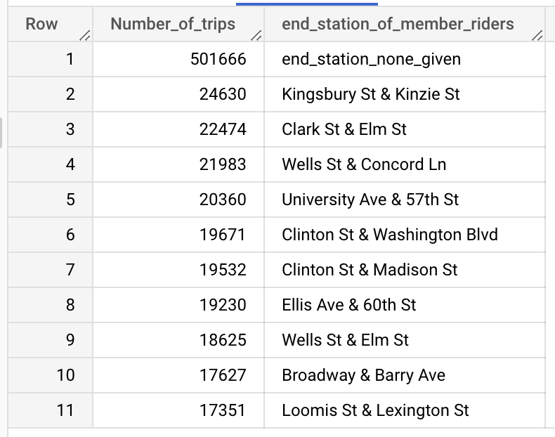

SELECT COUNT (cleaned_end_station_name) AS Number_of_trips, cleaned_end_station_name AS end_station_of_member_riders

FROM `capstone-1-abraham.Trip_data_v3.BikeTrips_todos_v2`

GROUP BY

cleaned_end_station_name

Order by

COUNT (cleaned_end_station_name) DESC

LIMIT 11

**Visualizations**

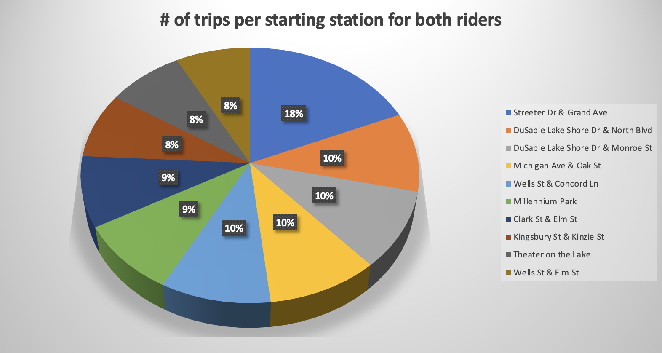

**Data category 6 – Start latitude and longitude**

**SMART Question eight:** “What was the distribution of rides starting point per longitude for both casual and member riders in the last 12 months?”

**SMART Question nine:** “What was the distribution of rides starting point per latitude for both casual and member riders in the last 12 months?”

**Answer:** Although with SQL I can count the trips at any time, unfortunately, because I’m using a free account, I cannot export that much data from BIGQUERY, therefore I wouldn’t be able to visualize the data and make some findings. I will try to answer this question with R later.

**Data category 7 – End latitude and longitude**

**SMART Question ten:** “What was the distribution of rides ending point per longitude for both casual and member riders in the last 12 months?”

**SMART Question eleven: “**What was the distribution of rides ending point per latitude for both casual and member riders in the last 12 months?”

**Answer:** Although with SQL I can count the trips at any time, unfortunately, because I’m using a free account, I cannot export that much data from BIGQUERY, therefore I wouldn’t be able to visualize the data and make some findings. I will try to answer this question with R later.